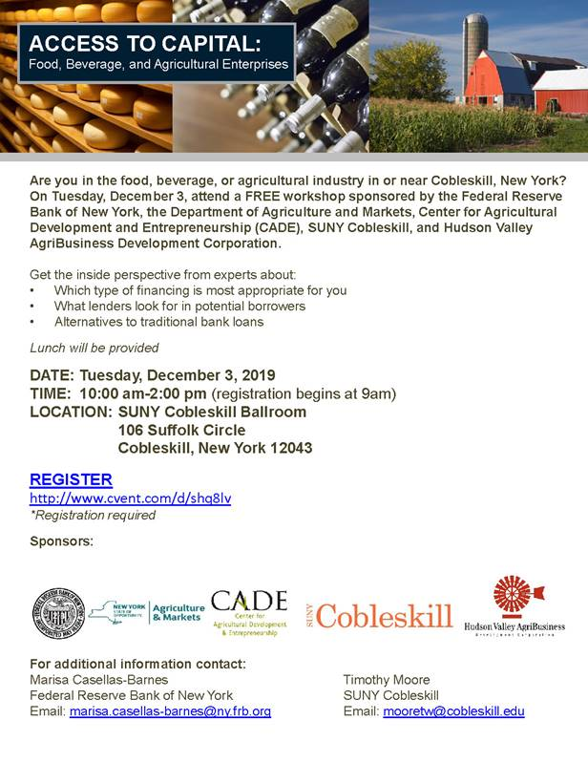Folks… A very good annual FREE workshop for ag / hort producers. Info below; register soon at:  <https://www.newyorkfed.org/smallbusiness/access-to-capital>